This Quick Reference Guide outlines how supervisors will approve time off requests in ADP via SuccessFactors.
- Approved time off requests will flow to the timecard

Accessing SuccessFactors
Click Employee Launchpad (SuccessFactors) from https:// www.purdue.edu/hr/global/index.php
- Log in using Purdue Career Account ID and Password.

Locate and click the ADP tile | 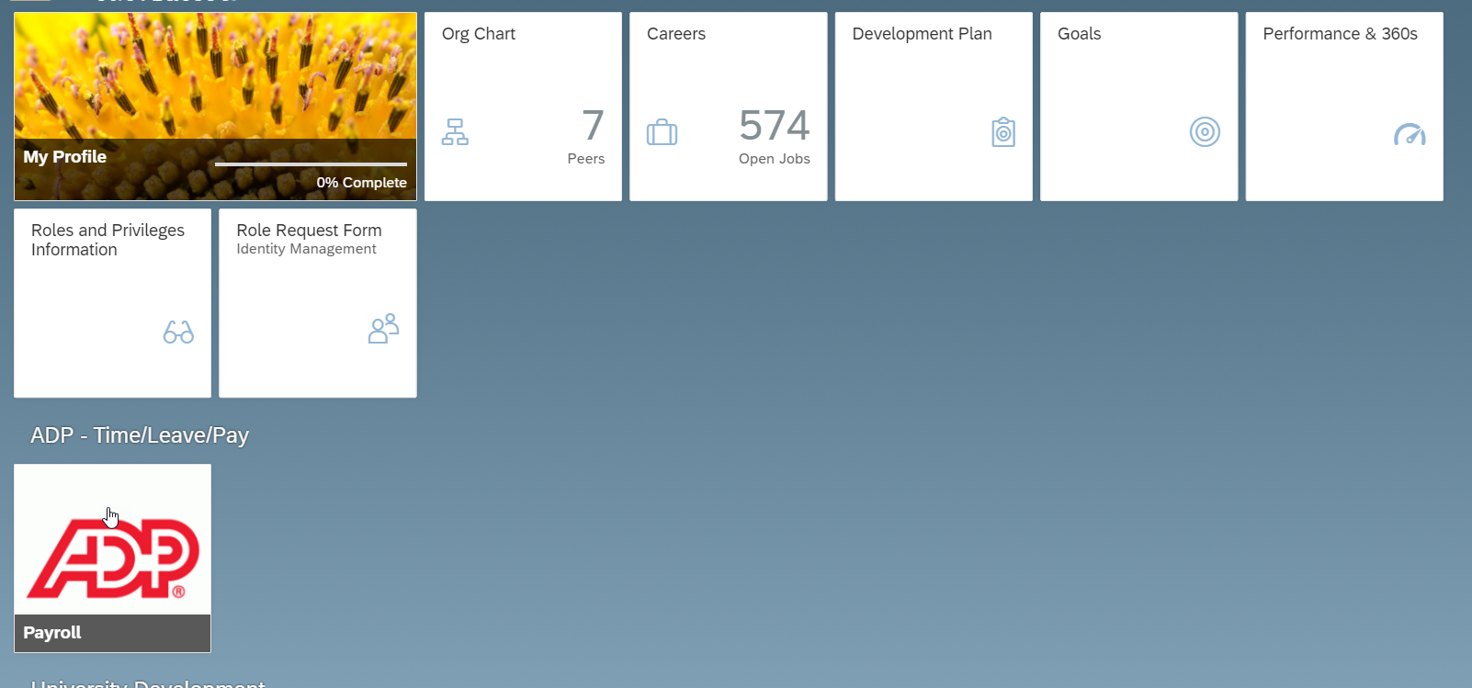

Review Requests
Click My Team

Select Workforce Management  Click Dashboard | 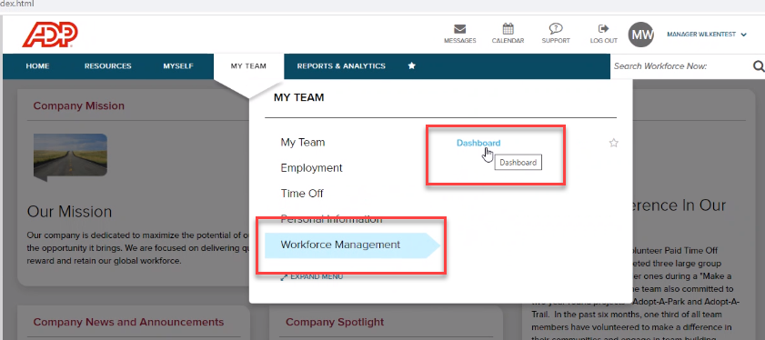
Under My Notifications  - Click Leave of Absence Requests to view all requests  You could also view leaves by selecting employee name in the Manage Leave of Absence tile | 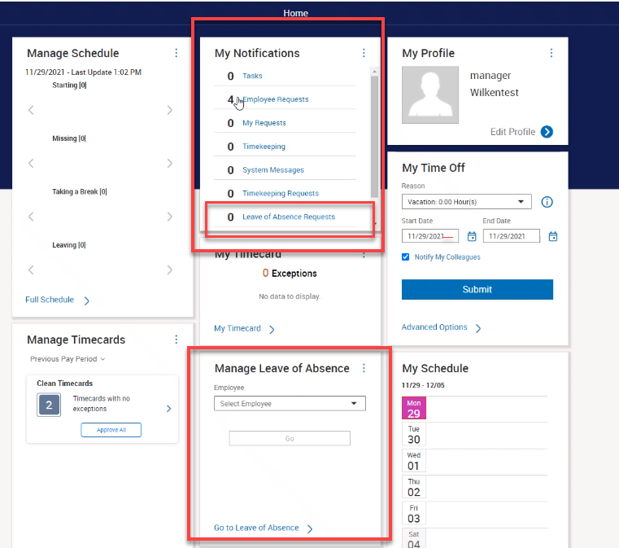
Employee Requests are displayed.  - Click individual request to review additional information or details | 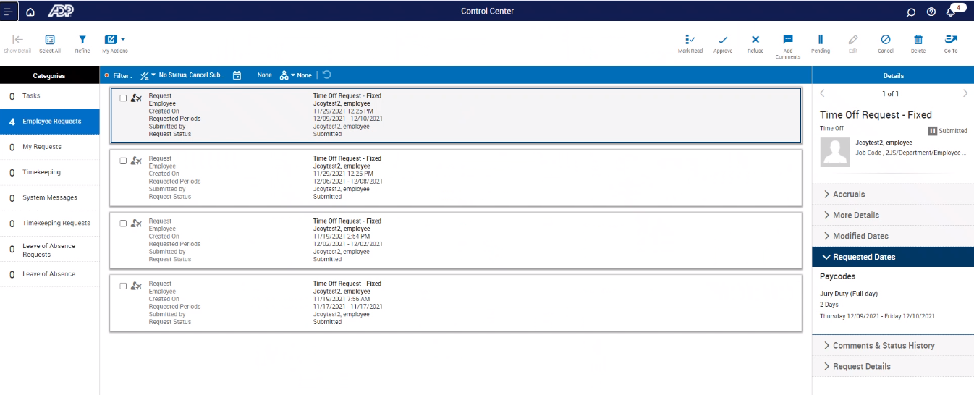
The Details displayed provide additional information about Accruals, More Details, Requested Dates, Pay Codes, Comments and Status History and Request Details.
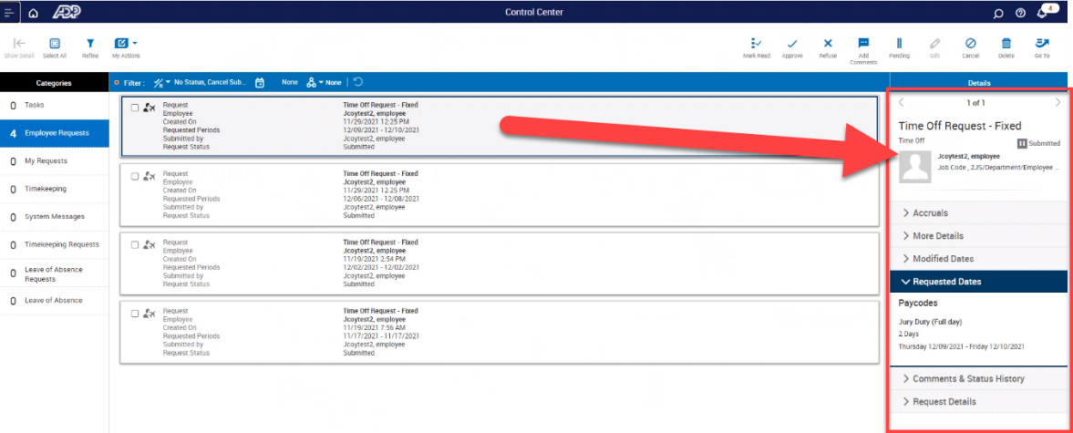

Click Approve to approve request; Click Refuse to deny request; Click Add Comments to add comments, when applicable
- Requests are approved individually

